NORFOLK COUNTY COUNCIL has made a Temporary Traffic Order affecting the U69359 Sandy Lane from its junction with C640 Martham Road for a distance of 30 metres north westwards in the PARISH OF SOMERTON because of new water connection works.

The road will be temporarily closed (except for access) from 25th November 2019 to 6th December 2019 for the duration of the works, expected to be 12 days within the period.

Alternative route is via: Sandy Lane, Cottage Road, Martham Road.

(If necessary the restriction could run for a maximum period of 18 months from the date of the Order).

Penalty: £1000 maximum fine on conviction and/or endorsement for contravention.

In the event of the start date being delayed the new start date will be displayed on site in advance.

The person dealing with enquiries at Norfolk County Council is Martin Dixon (Community and Environmental Services) Telephone 0344 800 8020.

Dated this 22nd day of November 2019

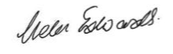

Helen Edwards
Chief Legal Officer

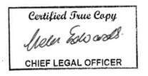

County Hall
Martineau Lane
Norwich
NR1 2DH



